Frontend UI Design — Introduction
- User-Friendly Interface — Provides a simple and easy-to-use interface for all OLMS users.
- Consistent Design — Maintains the same colors, fonts, buttons, and layout across all pages.
- Easy Navigation — Uses clear navigation bars, sidebars, and menus for quick access.
- Responsive Layout — Designed to work properly on computers, tablets, and mobile devices.
- Interactive Elements — Includes buttons, forms, cards, tables, icons, and progress indicators.
- Role-Based UI — Provides separate interfaces for Students, Teachers, and Admins according to their activities.
- Visual Learning Experience — Uses course cards, lecture sections, videos, quizzes, and progress displays.
- Modern Appearance — Uses a clean blue-and-white theme to create a professional educational interface.

vv

Dumy interface design

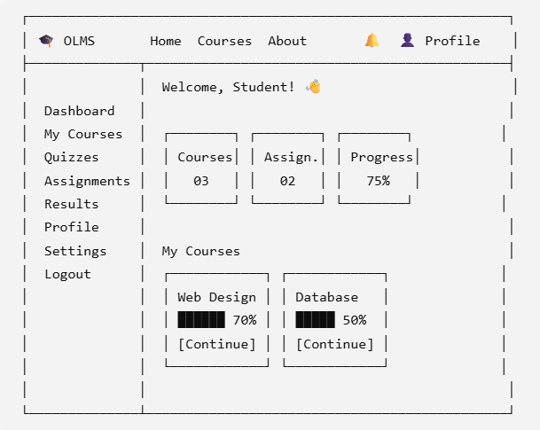

Procedure

- Homepage — Introduces OLMS with navigation, featured courses, and key learning features.
- Login Page — Provides a clean interface for users to enter their login credentials.
- Registration Page — Allows new users to create an OLMS account through a registration form.
- Student Dashboard — Displays enrolled courses, assignments, quizzes, progress, and recent activities.
- Teacher Dashboard — Provides teachers with interfaces to manage courses, lectures, assignments, and students.
- Admin Dashboard — Provides administrators with interfaces to manage users, courses, subjects, and reports.
- Course List Page — Displays available courses with search, categories, and enrollment options.
- Course Details Page — Shows course information, lectures, notes, quizzes, and assignments.
- Lecture Page — Provides the interface for viewing video lectures and accessing learning resources.
- Quiz Page — Displays questions, answer options, timer, and quiz navigation.
- Assignment Page — Allows students to view assignment details and submit their work.
- Results Page — Displays quiz, assignment, marks, and overall learning results.
- Profile Page — Allows users to view and update their personal profile information.
- Manage Users Page — Provides the admin interface for viewing, editing, and managing system users.

